VIT-AP University

SCOPE

DBMS Lab – L21+L22 Slot

**Task-4**

1. Consider the following relational database:

STUDENT (name, student#, class, major)

COURSE (course name, course#, credit hours, department) SECTION (section identifier, course#, semester, year, instructor) GRADE_REPORT (student#, section identifier, grade) PREREQUISITE (course#, presequisite#)

Specify the following queries in SQL on the above database schema.

(i) Retrieve the names of all students majoring in ‘CS’ (Computer Science).

(ii) Retrieve the names of all courses taught by Professor King in 1998

(iii) Delete the record for the student whose name is ‘Smith’ and whose student

number is 17.

(iv) Insert a new course <’Knowledge Engineering’, ‘CS4390’, 3, ‘CS’>

1. Information about a bank is about customers and their account. Customer has a name, address which consists of house number, area and city, and one or more phone numbers. Account has number, type and balance. We need to record customers who own an account. Account can be held individually or jointly. An account cannot exist without a customer. Draw an E-R diagram. Clearly indicate attributes, keys, the cardinality ratios and participation constraints.
2. Given the following relations  
   TRAIN (NAME, START, DEST)  
   TICKET (PNRNO., START, DEST, FARE) PASSENGER (NAME, ADDRESS, PNRNO.) Write SQL expressions for the following queries:

* List the names of passengers who are travelling from the start to the destination station of the train.
* List the names of passengers who have a return journey ticket.
* Insert a new Shatabti train from Delhi to Bangalore.
* Cancel the ticket of Tintin.   
  Note: Assume NAME of Train is a column of Ticket.

1. Given the following relations  
   Vehicle (Reg_no, make, colour) Person(eno, name, address) Owner(eno, reg_no)  
   Write expressions in the relational algebra to answer the following queries:- **(i)** List the reg_no of vehicles owned by John.

**(ii)** List the names of persons who own maruti cars.

**(iii)** List all the red coloured vehicle.

1. Information about films contains information about movies, stars and studios. Movies have a title, year of production, length and the film type. Stars have a name and address. Studios have a owner and a banner. Movies are shot in studios which own them. A movie is shot in only one studio. Stars are connected to one or more studios but can act in any film which may or may not be owned by the studio. Arrive at an E-R diagram. Clearly indicate attributes, keys, the cardinality ratios and participation constraints.
2. Consider the relations defined below: PHYSICIAN (regno, name, telno, city) PATIENT (pname, street, city)

VISIT (pname, regno, date_of_visit, fee)

Where the regno and pname identify the physician and the patient uniquely respectively. Express queries (i) to (iii) in SQL.

(i) Get the name and regno of physicians who are in Delhi.

(ii) Find the name and city of patient(s) who visited a physician on 31 August

2004.



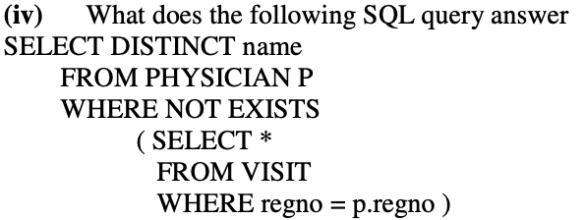

1. Consider the following relations:

BRANCH( bno, street, area, city, pcode, Tel_no, Fax_no)

STAFF( Sno, Fname, Lname, address, position , salary, bno)

Express the following queries in SQL:

(i) List the staff who work in the branch at ‘163 main street’

(ii) Find staff whose salary is larger than the salary of every member of staff at

branch B3.

1. (i) Consider employee (e_no, e_name, e_salary, d_code), dept (d_code, d_name) and dependent (depndt_name, e_no, relation). Show the names of employees in purchase and accounts departments with at least one dependent.

(ii) Consider student (std_id, std_name, date_of_birth, phone, dept_name). Put the data for a student with student id200, name arun, birth date 1st February, 1985, phone number (01110 32818 and dept name English in the student table.

(iii) A constraint named less_than_20 was defined on the field date_of_birth of table student. Delete this constraint.

(iv) Consider the table student and list names of students in the departments other than maths and computer.

(v) Consider employee table of (i) and list names of department(s) for which average salary for department is more than 10,000.

(vi) Create role named role_table that allows a user to create tables. Using role_table allow users kripa and reena to create tables.

(vii) Create a view emp_dep containing e_name and number of dependents from the tables employee and dependent of (i)

1. Consider the relations given below Borrower (id_no, name)

Book (accno., title, author, borrower_idno)  
**(a)** Define the above relations as tables in SQL making real world assumptions about the type of the fields. Define the primary keys and the foreign keys.

**(b)** For the above relations answer the following queries in SQL  
What are the titles of the books borrowed by the borrower whose id-no in 365.

**(i)** Find the numbers and names of borrowers who have borrowed books on DBMS in ascending order in id_no.

(ii) List the names of borrowers who have borrowed at least two books.

1. 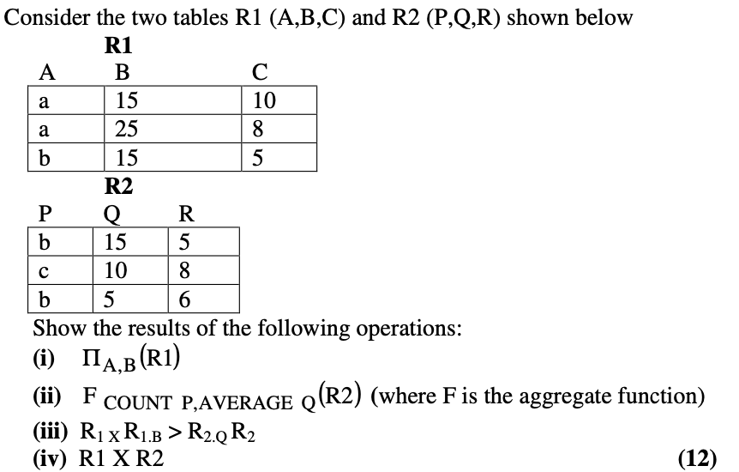
2. Consider the relations: PROJECT(proj#,proj_name,chief_architect)

EMPLOYEE(emp#,emp_name) ASSIGNED(proj#,emp#)

Use relational algebra to express the following queries:

(i) Get details of employees working on project COMP33.

(ii) Get the employee number of employees who work on all projects.

(iii) Get details of project on which employee with name 'RAM' is working.

1. Consider a table student (std_id, std_name, date_of_birth, percent_marks, dept_name). Write a QBE query to display names of Computer Science department students who have scored more than 80%.
2. Consider the relations EMP(ENO,ENAME,AGE,BASIC_SALARY)

WORK_IN(ENO,DNO) DEPT(DNO,DNAME,CITY) Express the following queries in SQL

(i) Find names of employees who work in a deptt. in Delhi.

(ii) Get the deptt. number in which more than one employee is working.

(iii) Find name of employee who earns highest salary in 'HR' department.

1. Express the following queries in SQL assumes that the data is stored in EMPLOYEE table with relevant fields.

(i) Display name, job, salary, and hire date of employee who are hired between May 10, 1975 and December 20, 1980. Order the query in ascending order of hire date.

(ii) Display name and hire date of employee who are employed after employee ‘RAGHA V’.

1. Consider the relations

EMPLOYEE(emp#, name)

ASSIGNED_TO(project#, emp#)

PROJECT(project#, project_name, chief)

Express the following queries in Relational Algebra

(i) Get details of employee working on both comp354 and comp345 project numbers.

(ii)Find the employee number of employee who do not work on project comp678